**HTTP Message Format**

http://yoursite.com/ folder1/folder2/index.php?Movies=1

| Server Details |~~~ URI ~~~|

URL : https://yoursite.com?folder1/folder2/index.php?Movies=1

https:// | yoursite.com | /folder1/folder2 | index.php | ?userid=1

protocol | your actual website's domain | folders | file which is requested | query

URL: Server Details + URI

URI: Path of the file to be interacted with

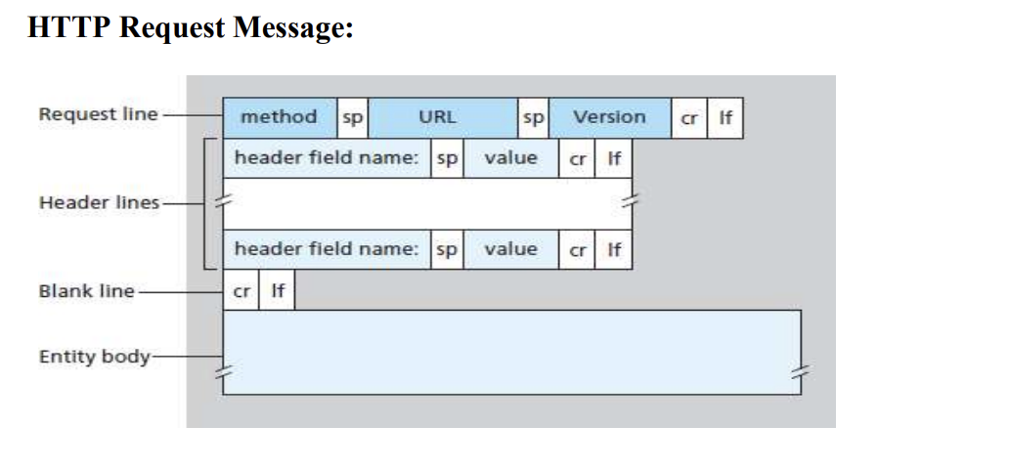Where, sp – space, cr – carriage return and lf – line feed.

**Method:**

There are five HTTP methods:

* **GET**: The GET method is used when the browser requests an object, with the requested object identified in the URL field.
* **POST**: With a POST message, the user is still requesting a Web page from the server, but the specific contents of the Web page depend on what the user entered into the form fields. If the value of the method field is POST, then the entity body contains what the user entered into the form fields.
* **PUT**: The PUT method is also used by applications that need to upload objects to Web servers.
* **HEAD**: Used to retrieve header information. It is used for debugging purpose.
* **DELETE**: The DELETE method allows a user, or an application, to delete an object on a Web server.

**URL**: Specifies URL of the requested object

**Version**: This field represents HTTP version, usually HTTP/1.1

**Header line**:

Ex:

Host: www.someschool.edu

Connection: close

User-agent: Mozilla/5.0

Accept-language: fr

The header line **Host: www.someschool.edu** specifies the host on which the object resides.

By including the **Connection: close** header line, the browser is telling the server that it doesn’t

want to bother with persistent connections; it wants the server to close the connection after

sending the requested object.

The **User-agent**: header line specifies the user agent, that is, the browser type that is making the

request to the server. Here the user agent is Mozilla/5.0, a Firefox browser.

The **Accept-language**: header indicates that the user prefers to receive a French version of the

object, if such an object exists on the server; otherwise, the server should send its default version.

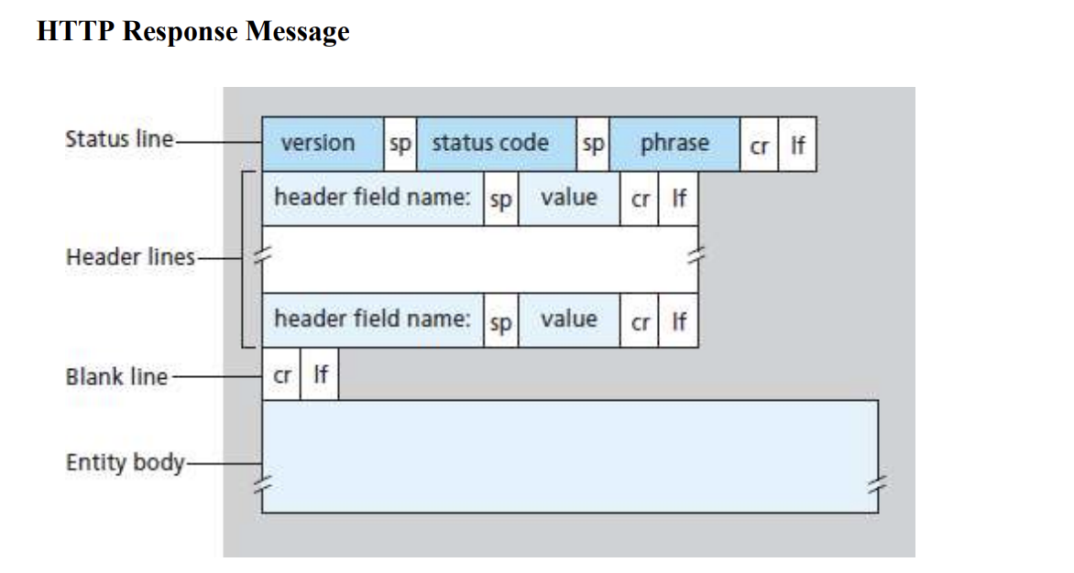

Ex:

HTTP/1.1 200 OK

Connection: close

Date: Tue, 09 Aug 2011 15:44:04 GMT

Server: Apache/2.2.3 (CentOS)

Last-Modified: Tue, 09 Aug 2011 15:11:03 GMT

Content-Length: 6821 Content-Type: text/html

(data data data data data ...)

The **status line** has three fields: the protocol version field, a status code, and a corresponding

status message.

Version is HTTP/1.1

The status code and associated phrase indicate the result of the request. Some common status codes and associated phrases include:

* 200 OK: Request succeeded and the information is returned in the response.
* 301 Moved Permanently: Requested object has been permanently moved; the new URL is specified in Location: header of the response message. The client software will automatically retrieve the new URL.
* 400 Bad Request: This is a generic error code indicating that the request could not be understood by the server.
* 404 Not Found: The requested document does not exist on this server.
* 505 HTTP Version Not Supported: The requested HTTP protocol version is not supported by the server.

**Header fields**:

* The server uses the **Connection**: close header line to tell the client that it is going to close the TCP connection after sending the message.
* The **Date**: header line indicates the time and date when the HTTP response was created and sent by the server.
* The **Server**: header line indicates that the message was generated by an Apache Web server; it is analogous to the User-agent: header line in the HTTP request message.
* The **Last-Modified**: header line indicates the time and date when the object was created or last modified.
* The **Content-Length**: header line indicates the number of bytes in the object being sent.
* The **Content-Type**: header line indicates that the object in the entity body is HTML text.